
Colorado Online Learning
www.col.k12.co.us

July 25, 2005

To Whom It May Concern:

This letter serves to recommend Mr. Clark Shah-Nelson for any position for which he may be eligible. Clark has been our online German teacher since our organization’s inception in 1998, and I have known him during my four-year tenure as executive director. In my opinion, Clark is an outstanding individual with unlimited potential. I would not hesitate to employ him in any capacity.

Clark is one of those rare persons that successfully combine reliability, work ethic, people skills and creativity. His students consistently rate him at the top of the scale, and I can’t recall ever receiving a complaint from them—a remarkable feat considering the nature of teenagers!

A pioneer in online learning, Clark developed his courses and regularly updates them as new technology innovations and tools become available. I particularly appreciate his emphasis on student learning. He understands that preparing cutting-edge course content is just one part of the equation in the teaching and learning process. The other parts are developing the relationships and personalizing the teaching experience to adapt to each student’s learning style—so that students truly master the material.

Clark writes well. His periodic messages to us reflect a sense of humor and natural kindness that are appreciated by all. Willing to expend extra-mile effort, he has traveled to our region to participate in trainings and share his talents with others.

Please give Clark your strongest consideration. He has my highest recommendation.

Sincerely,

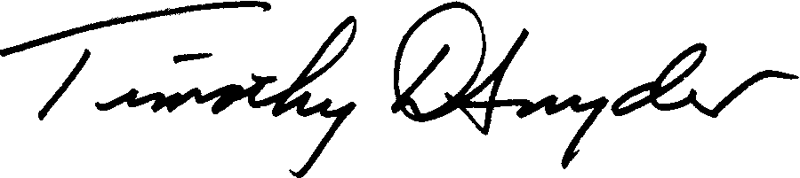

Timothy D. Snyder, Ed.D.
Executive Director

